Dates | Object | Type | Looks like | Where is the eclipse visible | Path of the eclipse
2018
Jan 31, 2018 | Lunar | Total |  | North/East Europe, Asia, Australia, North/East Africa, North America, North/East South America, Pacific, Atlantic, Indian Ocean, Arctic, Antarctica | 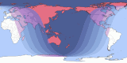
Jul 27 / Jul 28, 2018 | Lunar | Total |  | Much of Europe, Much of Asia, Australia, Africa, South in North America, South America, Pacific, Atlantic, Indian Ocean, Antarctica | 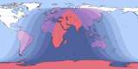
2019
Jan 20 / Jan 21, 2019 | Lunar | Total |  | Europe, Asia, Africa, North America, South America, Pacific, Atlantic, Indian Ocean, Arctic | 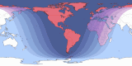
2021
May 26, 2021 | Lunar | Total |  | South/East Asia, Australia, Much of North America, South America, Pacific, Atlantic, Indian Ocean, Antarctica | 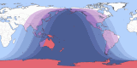
2022
May 15 / May 16, 2022 | Lunar | Total |  | South/West Europe, South/West Asia, Africa, Much of North America, South America, Pacific, Atlantic, Indian Ocean, Antarctica | 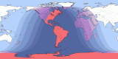
Nov 8, 2022 | Lunar | Total |  | North/East Europe, Asia, Australia, North America, Much of South America, Pacific, Atlantic, Indian Ocean, Arctic, Antarctica

2014-2015 Lunar Tetrad

2014-2015 Lunar Tetrad. 2014-2015 Lunar Tetrad.
The first three total eclipses in this lunar tetrad occurred on
April 15, 2014,
October 8, 2014,
April 4, 2015.
September 28, 2015.

